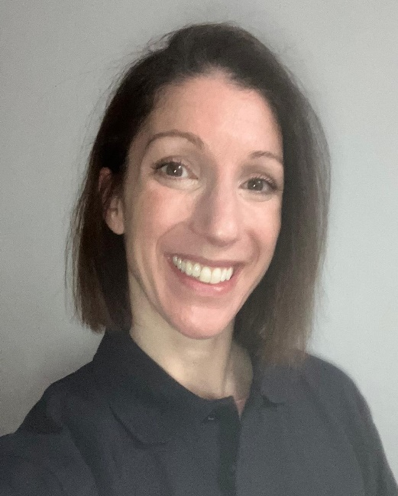





I offer:
- Initial Discovery Session
- Access to my Kick Start Weight Loss online programme, via email or app
- Periodic fitness, strength & body composition check-ins, as appropriate
- Food diary analysis & feedback
- Gym Programme to follow in-between PTs

Weight Loss Specialist Coach
Level 3 (NASM)
Yoga Teacher
200hrs – Himalaya Yoga Valley Centre
Academic:
HND Sports Science
My Qualifications
Personal Trainer Level 3 (NSCA)

I’m regulated by:
The Chartered Institute for the Management of Sport and Physical Activity (CIMSPA) Member number

Exercise to Music
Instructor
Level 2 (YMCA)
Gym Instructor
Level 2 (YMCA)
About me
Hi!
I’m Nicky and I am a certified Personal Trainer, group fitness & yoga teacher & a weight loss coach. My mission is empower my clients to achieve their fitness & wellbeing goals by giving them the movement, nutrition & mindset guidance they need to get results.
Happy to help with:
- Weight loss & toning/sculpting
- Boosting general fitness
- Training for sports events
- Overcoming injury
- Reducing stress & improving wellbeing

PERSONAL TRAINER PROFILE

Nicky
Rock
How do you book me?
Call: 07939 208806 Email: nicola@rockfitnessyoga.com
or ask at reception for my details.

